Experiment 3: Water Jug Problem
Aim
To solve the Water Jug Problem using Python and obtain the required amount of water using two jugs.

Algorithm (Short)
- Fill the 4L jug.
- Pour water into the 3L jug until it is full.
- Empty the 3L jug.
- Transfer the remaining water from the 4L jug to the 3L jug.
- Fill the 4L jug again.
- Pour water into the 3L jug until it is full. The remaining water in the 4L jug is the required amount.
Python Code
x = 4
y = 3

print("Fill 4L Jug")
print("Pour into 3L Jug")
print("Empty 3L Jug")
print("Transfer remaining water")
print("Fill 4L Jug again")
print("Pour into 3L Jug")
print("Result: 2 Litres in 4L Jug")

Output
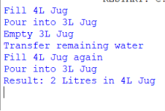

Result
The Water Jug Problem was successfully solved using Python, and the required 2 litres of water was obtained.

